**Assignment**

**Bad UI/UX:**

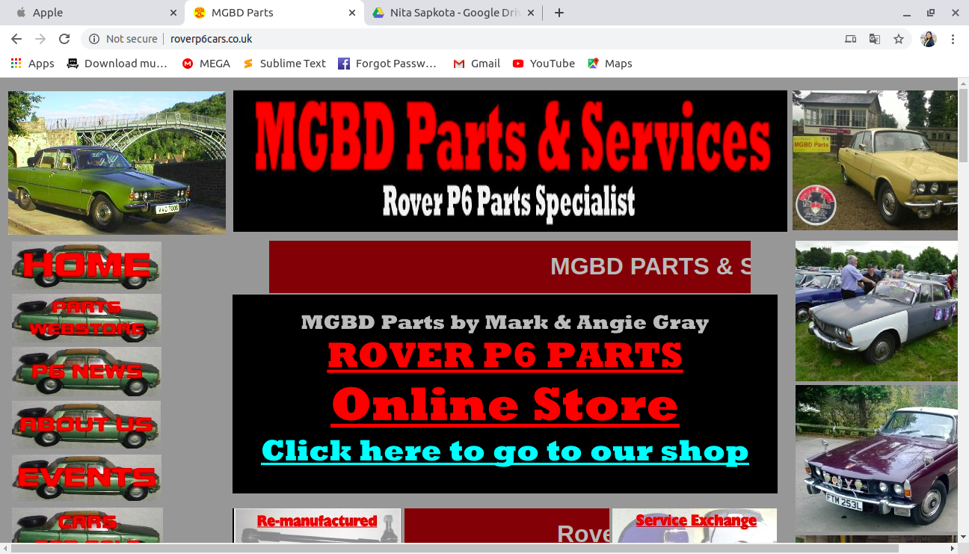

1) Rover p6 Parts Specialist

[http://www.roverp6cars.co.uk](http://www.roverp6cars.co.uk/)

-Color Contrast

-Alignment

-Spacing

-typography

-Proximity

-Unstable

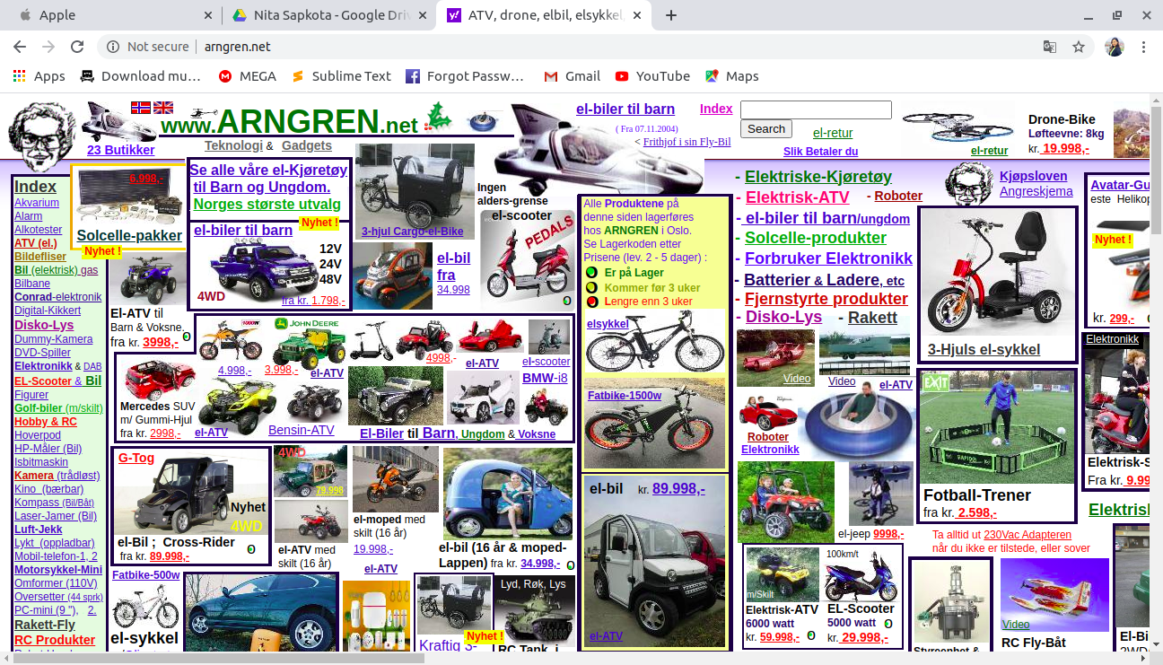 2) Arngren Net

<http://www.arngren.net/>

-Color Contrast

-Unstable

-Typography

-Alignment

-Spacing

-Heirarchy

-Unbalanced

**Good UI/UX:**

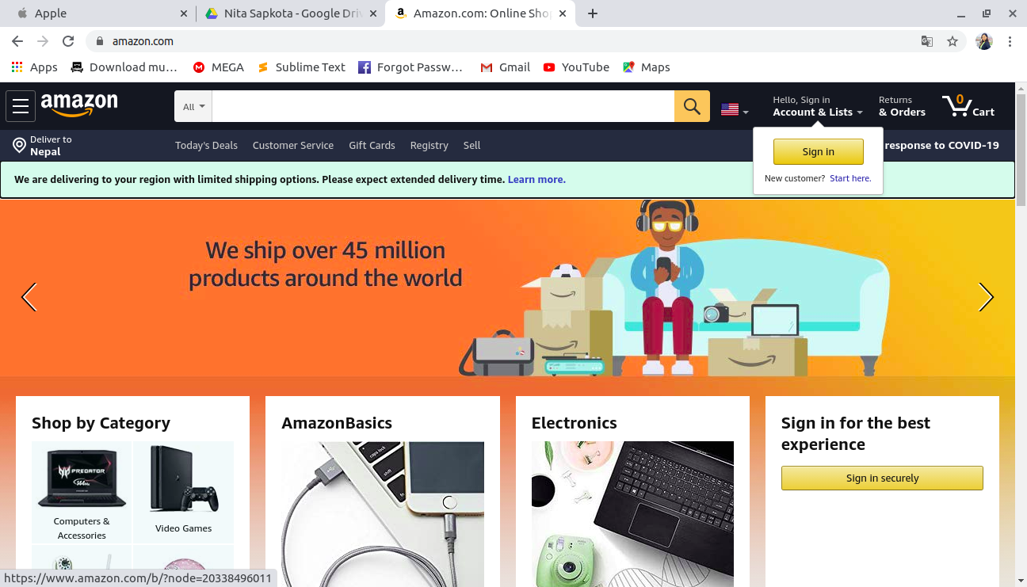

1) Amazon

<https://www.amazon.com/>

-Heirarchy

-Color Contrast

-Leading

-Typography

-Proximity

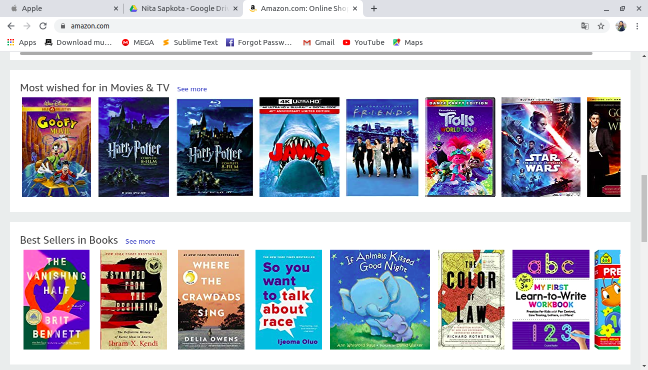

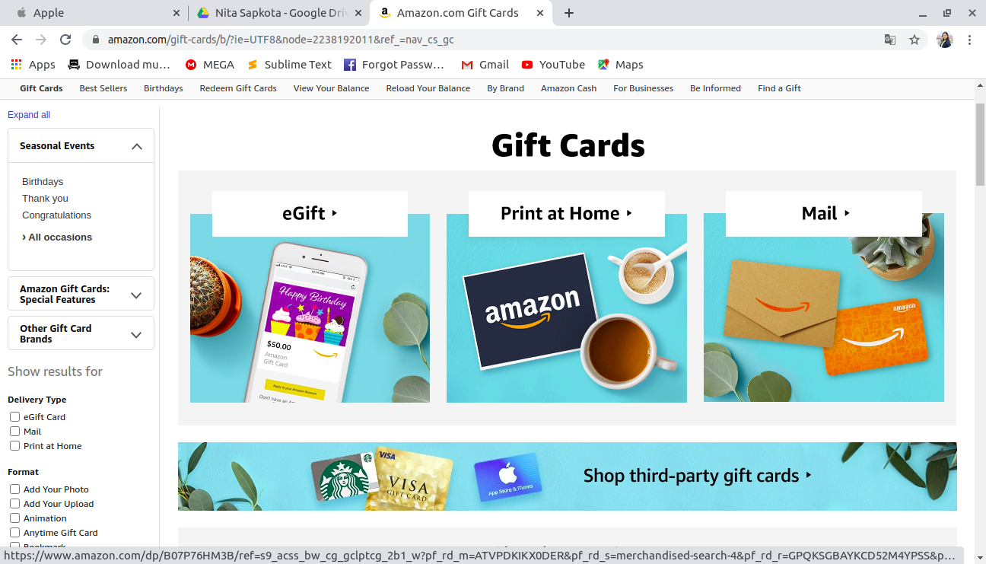

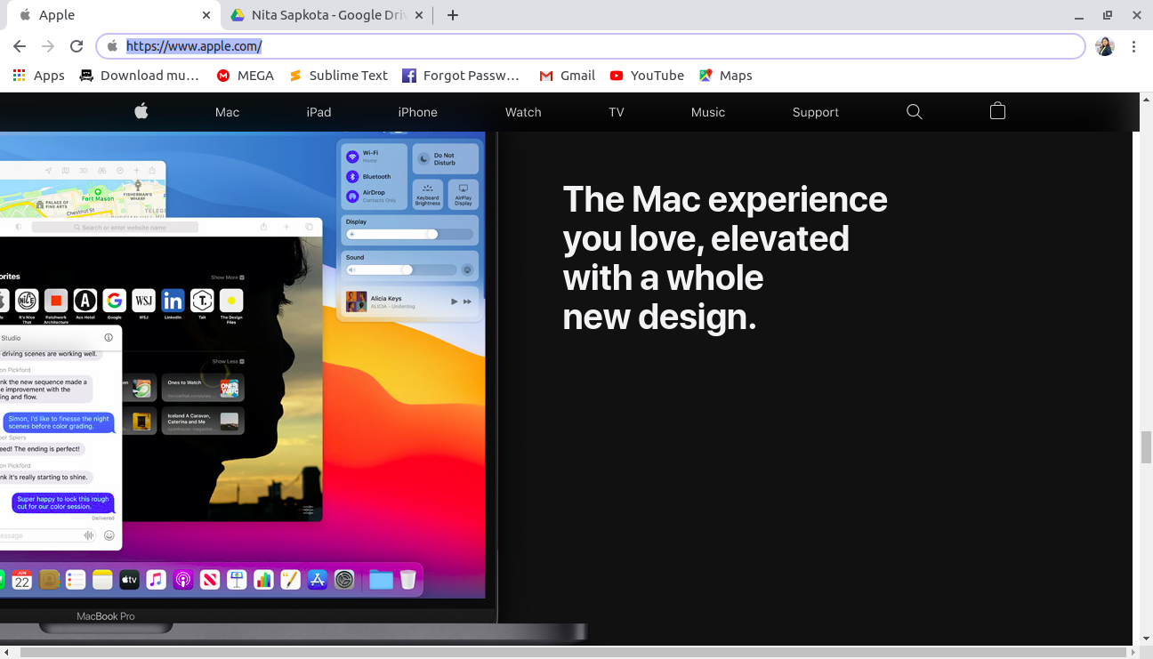

2) <https://www.apple.com/>

-contrast

-Alignment

-Repetation

-Heirarchy

-Proximity

-Typography

